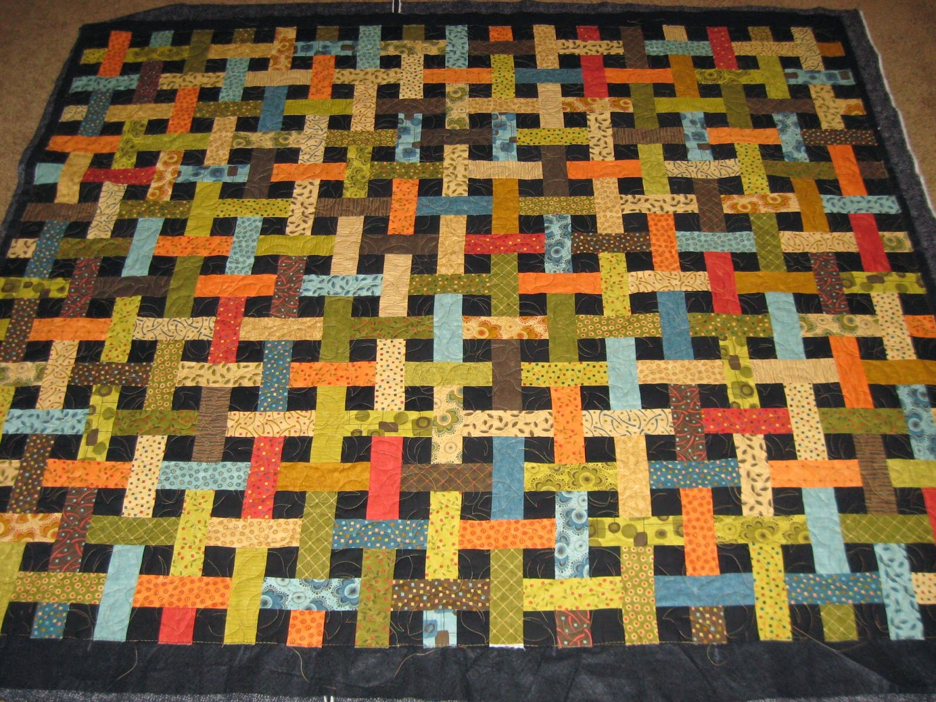
Basket Lattice

The Basket Lattice is a traditional pattern first published in the early 1920's by Ladies' Art Company. Using fabric strips sets and partial seams, we'll bring this traditional pattern into the 21st century and construct a lap quilt that will have others wondering how it was put together! It's up to you whether or not to share how easy it is.

40 different 2 1/2" x 44" strips for lattice (jelly roll works great!)
2 yards for background and binding (black used in sample)
Rotary cutter, ruler (2 1/2" x 6 1/2" is perfect) and small mat (instructions will be sent for cutting before class)
3 1/2 yards of backing fabric ( not needed in class )
4 zip lock bags for organizing sub units
Required pattern - “Basket Lattice” by Sheri Pape Designs
The pattern is readily available on the Internet or can be purchased from me with prior arrangement. Pattern cost is $9.00

Class length: 15 hours

Susan Congdon
Sewing since a young age, Susan has always enjoyed trying out new techniques. A long admirer of the woven effect in lattice quilts she was excited to learn how it was constructed. She will break it down into easy subunits and step by step lead you through the construction process. Susan has been teaching sewing and quilting for over 20 years and is known for her patience and encouragement.

